**2.34 Card game**. Consider the following card game with a well-Shuffled deck of cards. If you draw a red card, you win nothing. If you get a spade, you win $5. For any club, you win $10 plus an extra $20 for the ace of clubs.

(a) Create a probability model for the amount you win at this game. Also, find the expected winnings for a single game and the standard deviation of the winnings.

(b) What is the maximum amount you would be willing to pay to play this game? Explain.

**Answer:**

|  |  |  |  |  |  |
| --- | --- | --- | --- | --- | --- |
| Scenario (x) | Any Red Card | Spade | Club | Club+Ace | Total |
| $ Win | 0.00 | 5.00 | 10.00 | 30.00 |  |
| (a) Probability Model (P(x) | 0.50 | 0.25 | 0.23 | 0.02 |  |
| Cost per category (x*P(x)) | 0.00 | 1.25 | 2.31 | 0.58 | 4.13 |
| x-E(x) | -4.13 | 0.87 | 5.87 | 25.87 |  |
| (x-E(x))^2 | 17.10 | 0.75 | 34.40 | 669.02 |  |
| (x-E(x))^2 * P(x) | 8.55 | 0.19 | 7.94 | 12.87 | 29.54 |
|  |  |  |  |  |  |
|  |  |  |  |  |  |
| (b) Maximum amount to Play beyond which person will lose | 4.13 |  |  |  |  |
|  |  |  |  |  |  |
|  |  |  |  |  |  |
| Variance | 29.54 |  |  |  |  |
| (a) Standard Deviation if winning a single game (SQRT(Variance) | 5.44 |  |  |  |  |

– Probability Model as shown above

* Expected winning for a single game = 5*0.25+10*0.23+30*0.02 = $4.13 for a single game
* Standard deviation of the winning is : 5.44

1. Maximum amount to play for winning would be $4.13 as playing beyond this would be losing money in long run

2.40 Baggage fees. An airline charges the following baggage fees: $25 for the first bag and $35 for the second. Suppose 54% of passengers have no checked luggage, 34% have one piece of checked luggage and 12% have two pieces. We suppose a negligible portion of people check more than two bags.

(a) Build a probability model, compute the average revenue per passenger, and compute the corresponding standard deviation.

(b) About how much revenue should the airline expect for a  flight of 120 passengers? With what standard deviation? Note any assumptions you make and if you think they are justified.

**Answer:**

a)

|  |  |  |  |  |  |
| --- | --- | --- | --- | --- | --- |
| BAGS | 0 | 1 | 2 |  |  |
| Cost per Bag (x) | 0 | 25 | 60 |  |  |
| Probability Model (P(x) | 0.54 | 0.34 | 0.12 |  |  |
| Cost per category (x*P(x)) | 0.000 | 8.500 | 7.200 | Average Revenue per passenger(E(X)) | 15.70 |
| x-E(x) | -15.7 | 9.30 | 44.30 |  |  |
| (x-E(x))^2 | 246.49 | 86.49 | 1962.49 |  |  |
| (x-E(x))^2 * P(x) | 133.1046 | 29.4066 | 235.4988 |  |  |
|  |  |  |  |  |  |
| Variance | 398.01 |  |  |  |  |
| Standard Deviation (SQRT(Variance) | 19.95019 |  |  |  |  |

Answers:

* Probability Model as shown above
* Average Revenue per Passenger is: $15.70
* Standard Deviation will be 19.95019

b)

|  |  |  |  |  |
| --- | --- | --- | --- | --- |
| BAGS | 0 | 1 | 2 | Total |
| Cost per Bag (x) | 0 | 25 | 60 |  |
| Probability (P(x) | 0.54 | 0.34 | 0.12 |  |
| Cost per category (x*P(x)) | 0.000 | 8.500 | 7.200 | 15.700 |
| x-E(x) | -15.70 | 9.30 | 44.30 |  |
| (x-E(x))^2 | 246.49 | 86.49 | 1962.49 |  |
| (x-E(x))^2 * P(x) | 133.1046 | 29.4066 | 235.4988 | 398.01 |
|  |  |  |  |  |
| Total Number of Passenger | 120 |  |  |  |
| Average Revenue Per Passenger E(x) | 15.70 |  |  |  |
| Total Revenue from 120 passengers | 1884.00 |  |  |  |
|  |  |  |  |  |
| Variance | 398.01 |  |  |  |
| Standard Deviation (SQRT(Variance) | 19.95018797 |  |  |  |

Answers: We will use the same probability model and calculation as stated above

* Revenue from 120 passengers will be $1884
* Standard deviation will remain same as 19.9501

2.42 Selling on Ebay. Marcie has been tracking the following two items on Ebay:

• A textbook that sells for an average of $110 with a standard deviation of $4.

• Mario Kart for the Nintendo Wii, which sells for an average of $38 with a standard deviation of $5.

(a) Marcie wants to sell the video game and buy the textbook. How much net money (profits -losses) would she expect to make or spend? Also compute the standard deviation of how much she would make or spend.

(b) Lucy is selling the textbook on Ebay for a friend, and her friend is giving her a 10% commission (Lucy keeps 10% of the revenue). How much money should she expect to make? With what standard deviation?

**Answer:**

a)

Selling Price of Textbook on ebay = X and Selling price of Mario Kart =Y

Profit /Loss = Y-X

To calculate the expected Amount E(Y-X), variance and Standard Deviation of Marcie selling the video game and buying the text book.

Money spend by Marcie to buy the textbook = 110-38 = $72

Variance = 4^2 +5^2 = 16+25 =41

Standard deviation = SQRT(Variance) = SQRT(41) = 6.401

b)

Lucy will make money from commission= 0.1*X = 0.1*110 = $11

Standard Deviation = 0.1*4 = $0.4

2.46 Income and gender. The relative frequency table below displays the distribution of annual total personal income (in 2009 inflation-adjusted dollars) for a representative sample of 96,420,486 Americans. These data come from the American Community Survey for 2005-2009. This sample is comprised of 59% males and 41% females

(a) Describe the distribution of total personal income.

(b) What is the probability that a randomly chosen US resident makes less than $50,000 per year?

(c) What is the probability that a randomly chosen US resident makes less than $50,000 per year and is female? Note any assumptions you make.

(d) The same data source indicates that 71.8% of females make less than $50,000 per year. Use this value to determine whether or not the assumption you made in part (c) is valid.

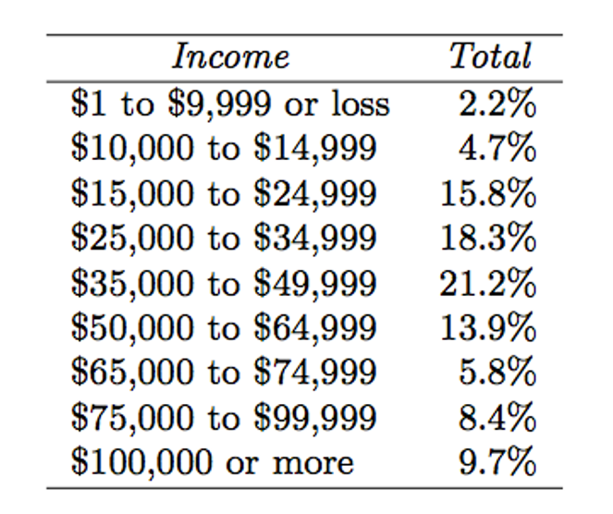

**Answer:**

1. Distribution of total personal income

Distribution graph of the total population income which is right skewed.

1. Probability that a randomly chosen US resident makes less than $50,000 per year

P(Person income is <50k)= 0.022+0.047+0.158+0.183+0.212 = 0.622

1. probability that a randomly chosen US resident makes less than $50,000 per year and is female

For this we need to make a tree structure: